HOME WORK
Reg.Number :-SUE/IS /20/ICT/084 Submission Due: 2023-06-08

Exercise 01:
- Create your first java program that will print, “Hello, Welcome to Object Oriented
Programming!”.
- Make the name of the class as ‘HelloWorld’.
b. Write the main method that will execute the print statement given.
c. Save the program by giving the file name same as class class and with the .java
extension.
d. Compile the program you created.
e. Execute the program you created
Answer :-
public class HelloWorld{

public static void main (String []args){
System.out.println("Hello, Welcome to Object Oriented Programming");
}
}
Output:-
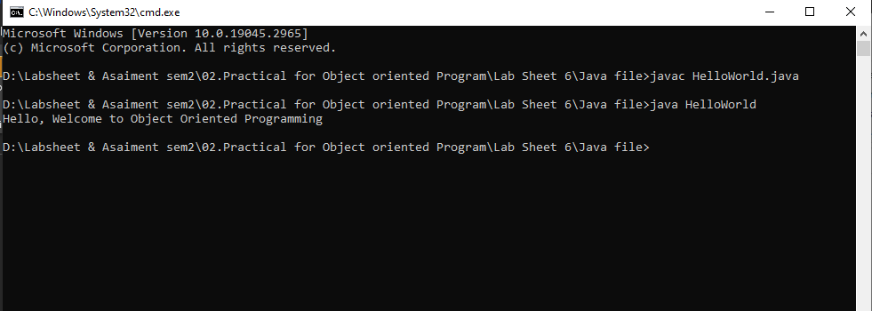

2. Create a class to display the following.
Name : Sam
Subject: OOP
Duration : 4 Months
Grade : A+

Answer :-
public class display{
public static void main (String []args){

System.out.println("Name : Sam");
System.out.println("Subject: OOP");
System.out.println("Duration : 4 Months");
System.out.println("Grade : A+");
}
}
Output:-
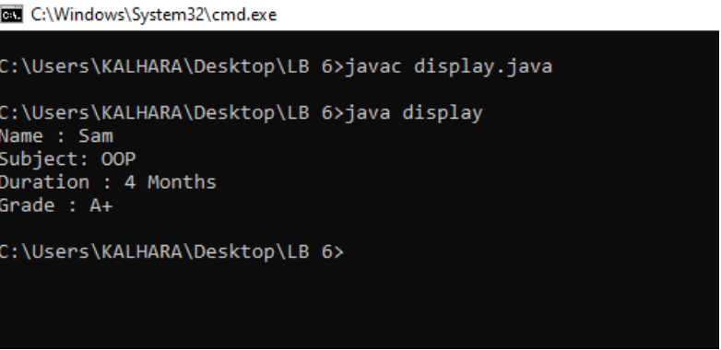

Exercise 02:
- Create a class called Student. Within this class
a.Define two variables namely id and name.
b. Initialize id to 1 and name to Kamal.
c. Create an object s1
d. Access the objects through reference variable.
Answer :-
public class Student{
int id =1;
String name="Kamal";

public static void main(String []args){

Student S1= new Student();

System.out.println("Students Name:-"+S1.id);
System.out.println("Students Name:-"+S1.name);
}
}

Output:-

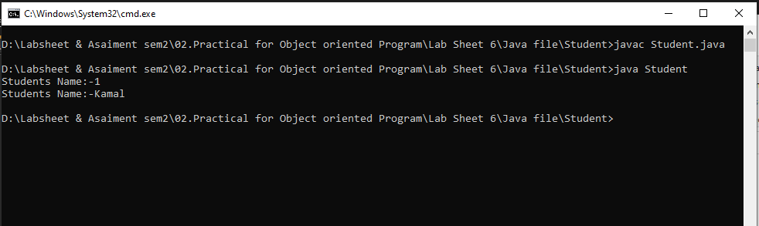

2. Modify the above program to bring the main method inside a separate class called
TestStudent.
a. Create an object s1
b. Access the objects through reference variable.

Answer :-
public class Student{
int id =1;
String name="Kamal";

}

class TestStudent{

public static void main(String []args){

Student S1= new Student();

System.out.println("ID:-"+S1.id);
System.out.println("Name:-"+S1.name);
}
}

Output:-

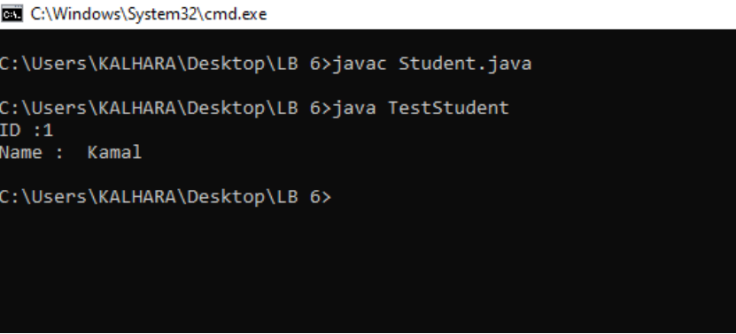

- Modify question 2 as per the following instructions:

a.Create a method called insertStudentRecord() inside Student class to initialize id and name
b.Create another method displayStudentDetails() inside Student class to display the student information.
c.Create another object s2 inside TestStudent.
d.Call the method insertStudentRecord() to enter student data and displayStudentDetails() method to display the details of the students
Answer :-
public class Student{
int id;
String name;
void insertStudentRecord(int Sid,String Sname){

id =Sid;
name=Sname;

}
void displayStudentDetails(){
System.out.println("ID :"+id);
System.out.println("Name : "+name);
}
}

class TestStudent{
public static void main (String []args){
Student S2 =new Student();
S2.insertStudentRecord(1," Kamal");
S2.displayStudentDetails();

}
}
Output:-

Exercise 03:

1. Create a class called Employee. Within the class,
a. Create the variables empid, name and salary (salary is a float value).
b. Create a method called insert() to enter employee data.
c. Next, creae another method display() to display the employee details.

2. Within the same program, create another class TestEmployee with the main method.
a. Here, create three instances, emp1, emp2 and emp3.
b. Call the method insert() to enter employee data and display() method to display the employee details

Answer :-
public class Employee{

String empid;
String name;
float salary ;

void insert(String Sempid,String Sname,float Ssalary ){

empid =Sempid;
name =Sname;
salary =Ssalary;

}

void display(){

System.out.println("EmpID: :"+empid);
System.out.println("Name : "+name);
System.out.println("sSlary :"+salary);
}

}

class TestEmployee{

public static void main(String[] args) {

Employee emp1 =new Employee();
Employee emp2 =new Employee();
Employee emp3 =new Employee();

emp1.insert("EMP001","Saman",10000);
emp1.display();
emp2.insert("EMP002","Kumara",20000);
emp2.display();
emp3.insert("EMP003","Kalhara",50000);
emp3.display();

}
}

Output:-
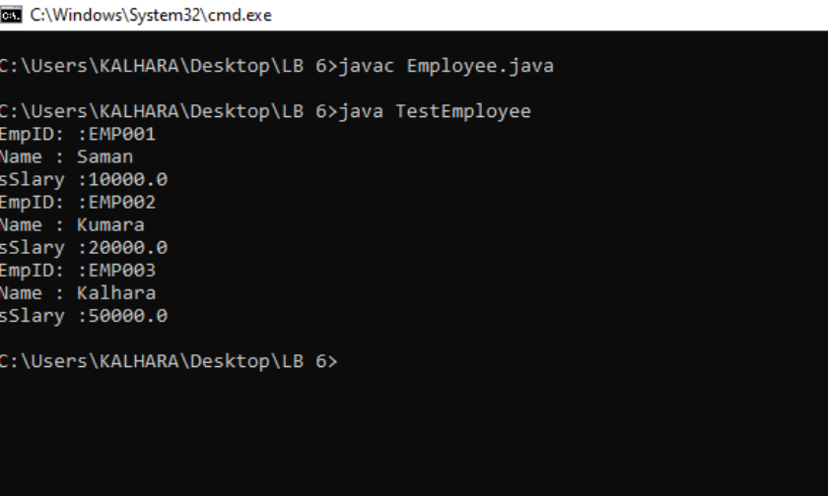

Exercise 04:
1. Create a class called MyName to print your name
2. Create a class to display the following
Java is an example for OOP
It is a pure Object Oriented language

Answer :-
public class MyName{

public static void main(String[] args) {
System.out.println("My Name Is Kalhara");
}
}

Output:-

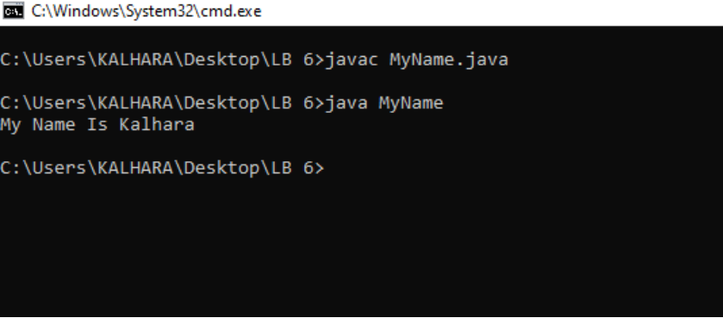

3.
• Create a class called Rectangle. Within the class,
I. Create the variables length and width.
II. Create a method called insert() to enter rectangle details.
III. Next, creae another method calculateArea() to calculate the area of the given rectangle.

• Within the same program, create another class TestRectangle with the mainmethod.
I. Here, create two instances, rect1 and rect2.
II. Call the method insert() to enter length and width values of rectangle andcalculateArea() method to display the area of the rectangles.

Answer :-
import java.util.Scanner;

public class Rectangle{

int length;
int width;

void insert(){

Scanner scanner = new Scanner(System.in);

System.out.print("Enter You length:");
length =scanner.nextInt();

System.out.print("Enter You width:");
width =scanner.nextInt();

}

static int calculateArea(int length,int width){
return length*width;
}

}

class TestRectangle{

public static void main(String[] args) {

Rectangle rect1 = new Rectangle();

rect1.insert();
System.out.println("calculateArea is "+rect1.calculateArea(rect1.length,rect1.width));

Rectangle rect2 = new Rectangle();

rect2.insert();
System.out.println("calculateArea is "+rect2.calculateArea(rect2.length,rect2.width));

}
}

Output:-

